CSA-07

Lab Experiments 11-15

11. IoT based smart home applications. 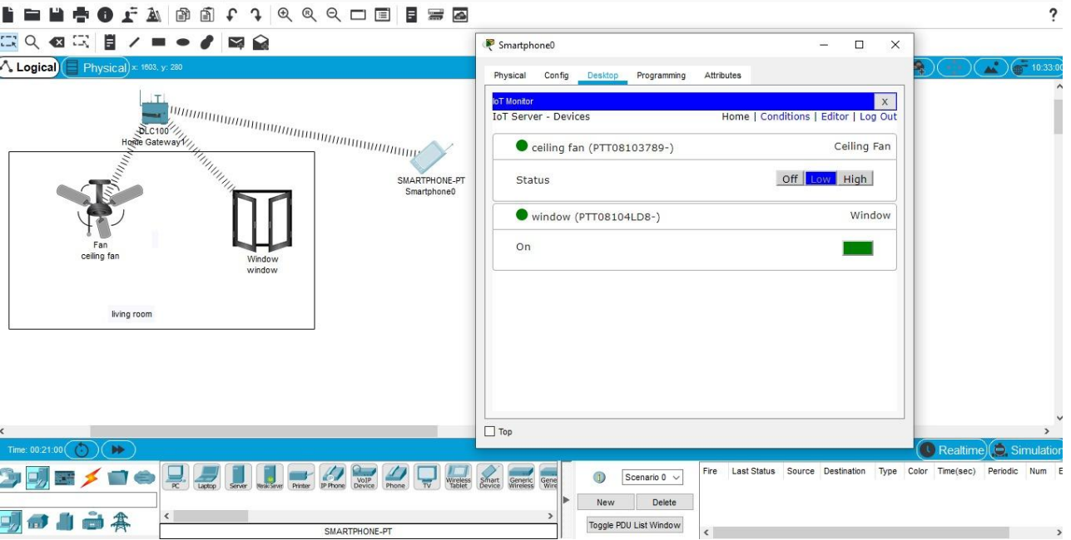  
  
12. Implementation of IoT based smart gardening.

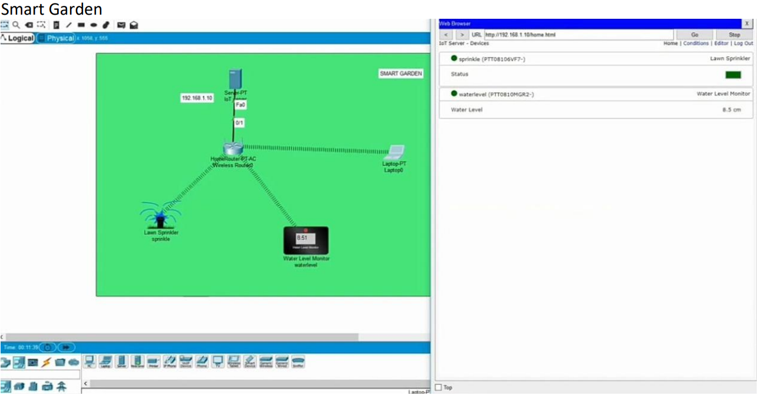  
  
13. Implementation of IoT devices in networking. 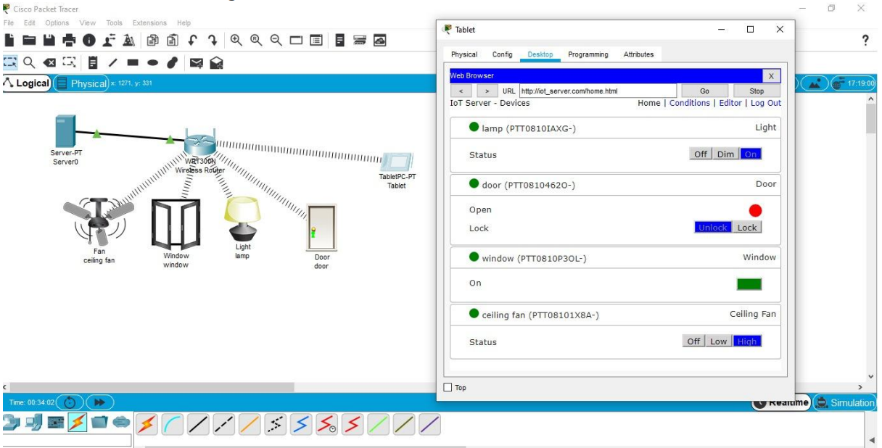  
  
14.Simulating X, Y, Z Company Network Design and simulate using Packet Trace.

15.Make computer lab in cisco packet tracer.

